

**EC60064**

**Biomedical System Engineering and Automation**

**Experiment-4**

**Report**

Prepared by

Sai Joshitha Annareddy

21EE62R10

MTech

Control systems engineering

Question 1:

Problem Statement:

The signal in the file emg-dog2.dat was recorded from the crural diaphragm of a dog using fine-wire electrodes sewn in-line with the muscle fibers and placed 10 mm apart. The signal represents two cycles of breathing, and has been sampled at 10 kHz. (See also the file emg-dog2. m)

1. Write a Python program to perform full-wave rectification (absolute value) or halfwave rectification (threshold at zero, with the mean value of the signal being zero).
2. Apply a bandpass filter of lower and higher cutoff frequency in the range 20 to 50 Hz to the result.
3. Analyze and evaluate the results with the two methods of rectification and at least two different lowpass cutoff frequencies.
4. Compare the results with the envelope provided in the file emg-dog2-env.dat.

EMG data signal:

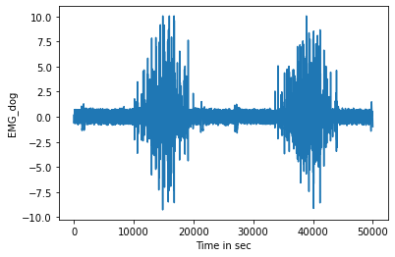

**Figure1: EMG_DOG_data_signal**

Full wave rectification: The signal is rectified by taking the absolute value .

The graph of full wave rectified signal is given below:

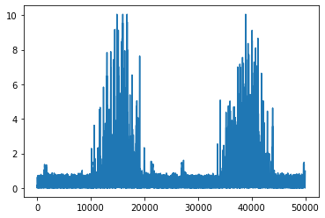

**Figure 2: Full wave rectified signal**

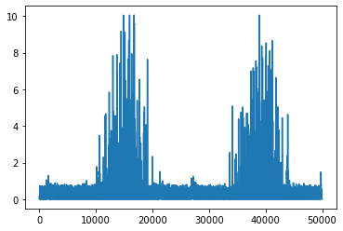

**Figure 2: Half wave rectified signal**

**Butterworth lowpass filter with cut off frequency 50hz and 40hz**

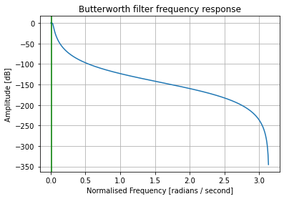

**Figure 3: Butterworth Lowpass filter with cut off frequency 50hz**

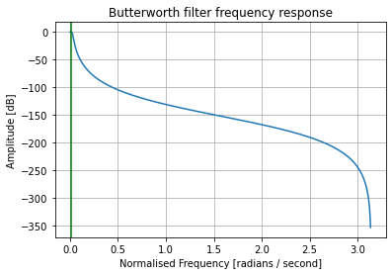

**Figure 4: Butterworth Lowpass filter with cut off frequency 40hz**

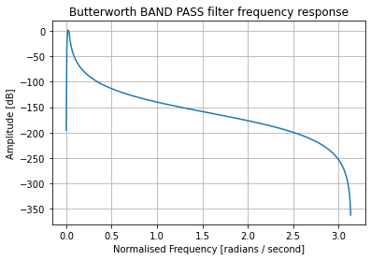

**Figure5:Butterworth Bandpass filter with band of 20-50hz**

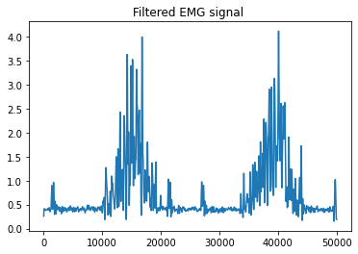

**Figure6:** Butterworth **lowpass_filtered_fullwaverectified_emgsig_50hz**

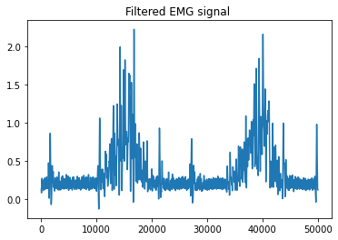

**Figure 7:** Butterworth **lowpass_filtered_halfwaverectified_emgsig_50hz**

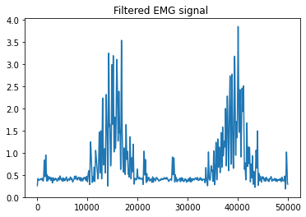

**Figure 8:** Butterworth **lowpass_filtered_fullwaverectified_emgsig_40hz**

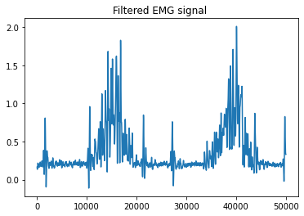

**Figure 9:** Butterworth **lowpass_filtered_halfwaverectified_emgsig_50hz**

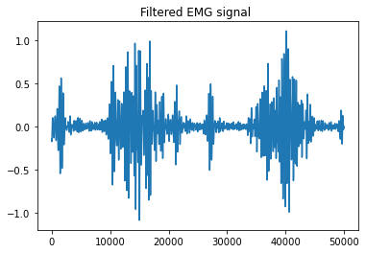

**Figure 10:** **Butterworth** **bandpass_filtered_halfwaverectified_emgsig_20-50hz**

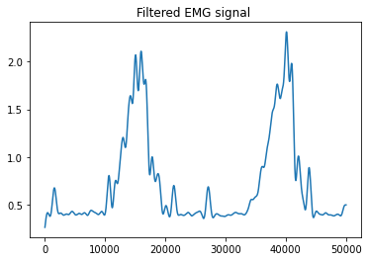

**Figure 11:Lowpass filtered signal with cut off frequency 10hz and half wave rectified**

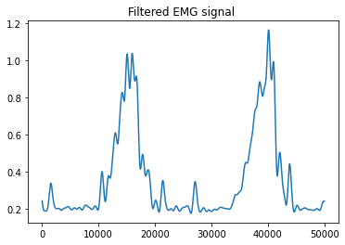

**Figure 12:Lowpass filtered signal with cut off frequency 10hz and Full wave rectified**

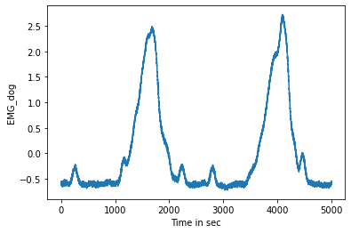

**Figure 13: EMG_envelope_signal**

**Conclusions:**

**Python program for full wave and half wave rectification is given in ipynb files**

**After passing through Butterworth filters the outputs are observed.**

**The lower cut off frequency 40hz will remove more noises and is smoother as compared to higher cut off frequency 50hz.This is same for both half wave and full wave rectified signal.**

**In the two methods of rectification Full wave rectified signal is smoother compared to Half wave rectified filtered signal.**

**Low pass filtered output with 10hz is smoother compared to 40hz and 50hz.**

**The full wave rectified signal with cutoff frequency 10hz butterworth lowpass filter looks similar to envelope given in question.**

Question 2.

Develop a program to derive the envelogram. (pg no 255)

1. Apply the procedure to the PCG signals in the files pec1.dat, pec33.dat, and pec52.dat. (all sampled at 4kHz)
2. Extend the procedure to average the envelograms over several cardiac cycles.
3. Count the average number of zero crossings over a window of 70ms.
4. How will you handle the variations in the duration (number of samples) of the signals from one beat to another?

**Envelogram computation steps:**

**Before computing envelogram we need to find the location of s1 and s2 signals.**

**S1 location is found by finding the R peak because s1 is started immediately after R peaks.**

**S2 location is found by finding the dicrotic notch in carotid pulse signal.**

**Finding R peaks is done by using Pan Tomkins Algorithm**

**Steps in Pan Tomkins Algorithm:**

1. **Pass the signal through Butterworth band pass filter with band of 5-11hz**
2. **Pass the output of Butterworth filtered signal to derivative filter**
3. **Then the signal from derivative filter is squared**
4. **Pass the squared signal through integrator**
5. **Threshold at 40% of maximum value and find the R peaks**

**Find the interval between 2 R peaks and perform Envelogram**

**Steps for computation of Envelogram**

1. **Compute DFT or FFT of PCG signal**
2. **Keep negative DFT as 0 (N/2+2 to N as 0)**
3. **Compute inverse DFT or inverse FFT (analytical signal)**
4. **Magnitude of resultant signal is envelogram**

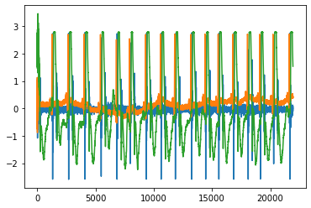

**Figure 14:Pec 1 signal with three channels 0 is PCG ,1 is ECG signal and 2 is carotid pulse signal.**

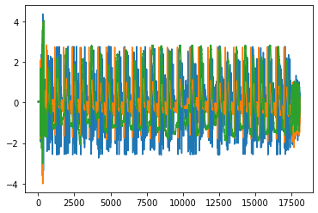

**Figure 15:Pec 33 signal with three channels 0 is PCG ,1 is ECG signal and 2 is carotid pulse signal.**

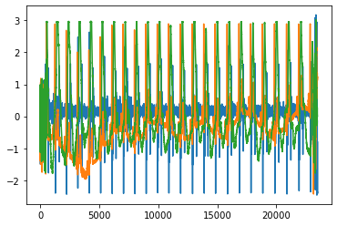

**Figure 16:Pec 52 signal with three channels 0 is PCG ,1 is ECG signal and 2 is carotid pulse signal.**

**R peaks detected by Pan Tompkins algorithm for three pec signals consisting of ecg signal in channel 1.**

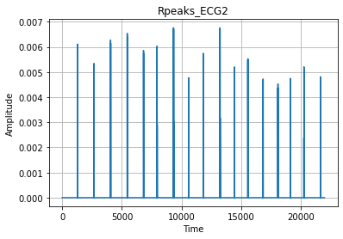

**Figure 17:Pec 52 signal rpeaks of ecg wave.**

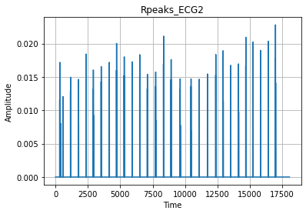

**Figure 18:Pec 33 signal rpeaks of ecg wave.**

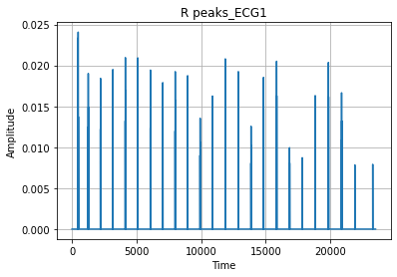

**Figure 19:Pec 1 signal rpeaks of ecg wave.**

**Now s1 s2 are detected for one cardiac cycle and envelogram is computed by following the steos mentioned above.**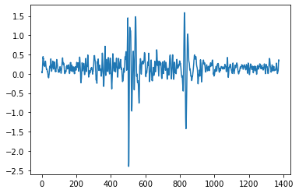

**Figure 20: s1 and s2(pcg signal for one cardiac cycle and its envelogram is below).**

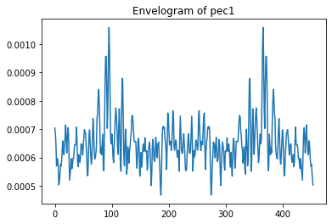

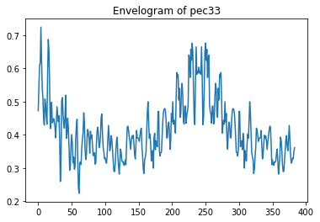

**Figure 21:s1 and s2(pcg signal for one cardiac cycle and its envelogram is above).**

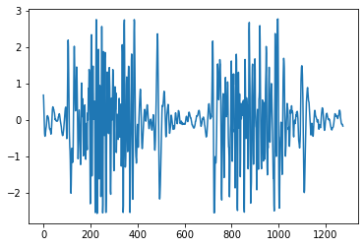

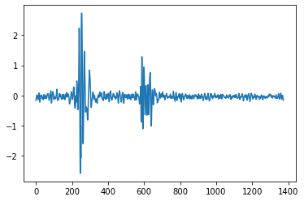

**Figure 22 and 23 corresponds to above cardiac cycle**

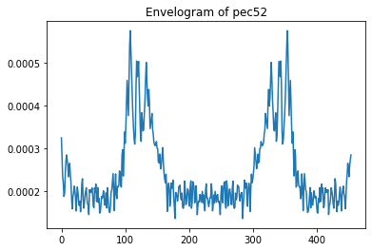

**Figure 22:s1 and s2(pcg signal for one cardiac cycle and its envelogram is above).**

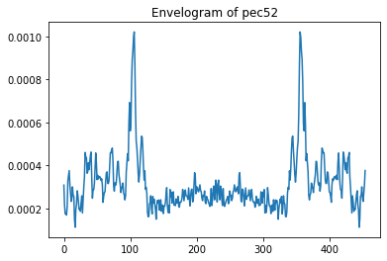

**Figure 23:avg envelogrampec52**

**Conclusions:**

**The figure 23 average envelogram gives correct information about s1 and s2 than the envelogram in figure 22.and also we can say average envelogram is smoother compared to normal one.**

**In order to handle equal no of samples s1 and s2 are properly detected and the cardiac cycle is taken correctly from 200 samples before s1 to 200 samples after s2.If the cardiac cycle length is not same then the zeros are added to it to compensate with other cardiac cycle.**

**Average no of zero crossings over the interval of 70ms for pec1,pec33 and pec 52 are given as** 0.23571428571428570.31071428571428570.14285714285714285 respectively.